sshpass: Login To SSH Server / Provide SSH Password Using A Shell Script
Author: Vivek Gite Last updated: January 13, 2017 37 comments

How do I login over ssh without using password less RSA / DSA public keys? How do I use ssh in a shell script? How do I login non-interactivly performing password authentication with SSH and shell scripts?
You can use the sshpass command to provide the password for ssh based login. It is a non-interactive ssh password auth tool. From the man page:
ADVERTISEMENT
sshpass is a utility designed for running ssh using the mode referred to as “keyboard-interactive” password authentication, but in non-interactive mode.
ssh uses direct TTY access to make sure that the password is indeed issued by an interactive keyboard user. Sshpass runs ssh in a dedicated tty, fooling it into thinking it is getting the password from an interactive user.
The command to run is specified after sshpass’ own options. Typically it will be “ssh” with arguments, but it can just as well be any other command. The password prompt used by ssh is, however, currently hardcoded into sshpass.
WARNING! These examples considered the least secure as simple ps command can expose password to all users on the same host. I highly recommend using ssh’s public key authentication or keychain software to set up secure passwordless SSH access.

Install sshpass under Debian / Ubuntu Linux
Type the following command:
$ sudo apt-get install sshpass
Sample outputs:
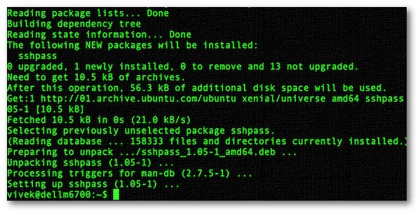
Fig.01: Installing sshpass on Debian/Ubuntu Linux

Install sshpass under RHEL/CentOS Linux
First, enable EPEL repo and type the following yum command:
$ sudo yum install sshpass
If you are using Fedora Linux, type:
$ sudo dnf install sshpass

Patreon supporters only guides 🤓
- No ads and tracking
- In-depth guides for developers and sysadmins at Opensourceflare✨
- Join my Patreon to support independent content creators and start reading latest guides:
  - How to set up Redis sentinel cluster on Ubuntu or Debian Linux
  - How To Set Up SSH Keys With YubiKey as two-factor authentication (U2F/FIDO2)
  - How to set up Mariadb Galera cluster on Ubuntu or Debian Linux
  - A podman tutorial for beginners – part I (run Linux containers without Docker and in daemonless mode)
  - How to protect Linux against rogue USB devices using USBGuard
  - If your domain is not sending email, set these DNS settings to avoid spoofing and phishing
Join Patreon ➔

Install sshpass under Arch Linux
$ sudo pacman -S sshpass

Install sshpass under OpenSUSE Linux
$ sudo zypper install sshpass

Install sshpass under FreeBSD Unix
To install the port, enter:
# cd /usr/ports/security/sshpass/ && make install clean
To add the package, run:
# pkg install sshpass

How do I use sshpass in Linux or Unix?
Login to ssh server called server.example.com with password called t@uyM59bQ:
$ sshpass -p 't@uyM59bQ' ssh username@server.example.com
For shell script you may need to disable host key checking:
$ sshpass -p 't@uyM59bQ' ssh -o StrictHostKeyChecking=no username@server.example.com
Security unwise warning: The -p option should be considered the least secure of all of sshpass’s options. I recommend that you use ssh’s public key authentication.

A bash shell script example with SSHPASS
The syntax is:
SSHPASS='t@uyM59bQ' sshpass -e ssh vivek@server42.cyberciti.biz
SSHPASS='t@uyM59bQ' sshpass -e ssh vivek@server42.cyberciti.biz date
SSHPASS='t@uyM59bQ' sshpass -e ssh vivek@server42.cyberciti.biz w
SSHPASS='t@uyM59bQ' sshpass -e ssh -o StrictHostKeyChecking=no vivek@server42.cyberciti.biz
The password is passed as environment variable called SSHPASS.

Reading password from file
Another option is to read password from file using the -f option. The syntax is:
sshpass -f fileNameHere ssh user@server
Create a file as follows:
$ echo 'myPassword' &gt; myfile
$ chmod 0400 myfile
$ sshpass -f myfile ssh vivek@server42.cyberciti.biz

How do I backup /var/www/html using rsync?
Run rsync over SSH using password authentication, passing the password on the command line:
$ rsync --rsh="sshpass -p myPassword ssh -l username" server.example.com:/var/www/html/ /backup/
OR
$ SSHPASS='yourPasswordHere' rsync --rsh="sshpass -e ssh -l username" server.example.com:/var/www/html/ /backup/

How do I use sshpass with gpg encrypted file?
First, create a file as follows:
$ echo 'mySshPasswordHere' > .sshpassword
Now, encrypt a file using gpg command:
$ gpg -c .sshpassword
$ rm .sshpassword
Finally, use it as follows:
$ gpg -d -q .sshpassword.gpg > fifo; sshpass -f fifo ssh vivek@server1.cyberciti.biz
If you just type sshpass, you will see help screen as follows:
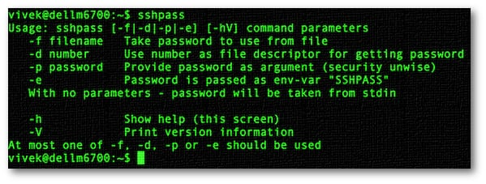
Fig.02: sshpass command in action

